**PERFORMANCE MANAGEMENT**

**USER GUIDE**

Contents

1. Purpose of this User Guide 1

2 How to Register yourself 2

3 Line Manager – Launch Performance Templates 3

4 Employee Complete Performance Agreement 5

4.1 How to capture KPAs & Objective / Goals & Outputs. 5

4.2 Capture Comments 6

4.3 Submit your template/results 7

4.4 Sign Off 7

5 Line Manager Process 8

# Purpose of this User Guide

This guide will help you to:

* Set up your KPAs and Outputs on a template via the new HR Manage web portal.
* Edit and communicate changes between you and your Line Manager.
* Submit and Sign Off once agreed on KPAs and Outputs.

# How to Register yourself

Click on the following link: <https://vut.hrmanage.za.net>

(the preferred browser is Google Chrome)

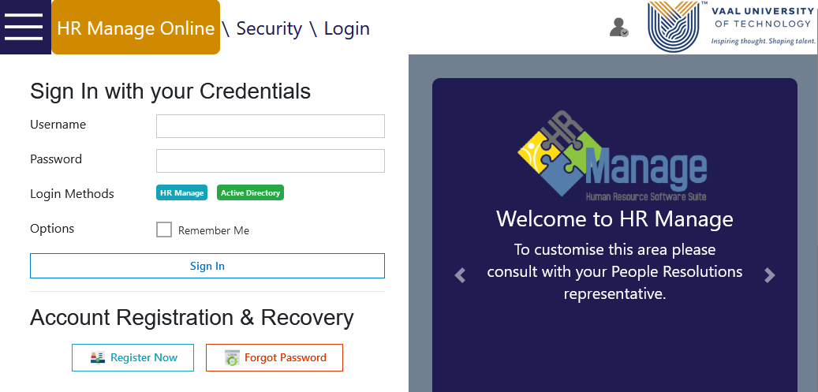

Click on Register Now if you do not have a profile yet.

3. Click on “Validate”

2. Capture your ID number in this space

1. Capture your Surname in this space

The following screen will appear. Complete ALL the fields.

Type your work number and cell Nr.

Type a few words that will help you to remember your password if you forget it.

Type your preferred name

Create a Username

Repeat the same password

Type any password

Ignore this section

Type any question and the answer in the space to the right

When done, click Save.

When done, you will see the following pop-up on your screen

You can now use the Username and Password to log into the system.

You will land on the following page. Click on the “Menu” icon, then on the “Performance Management” icon.

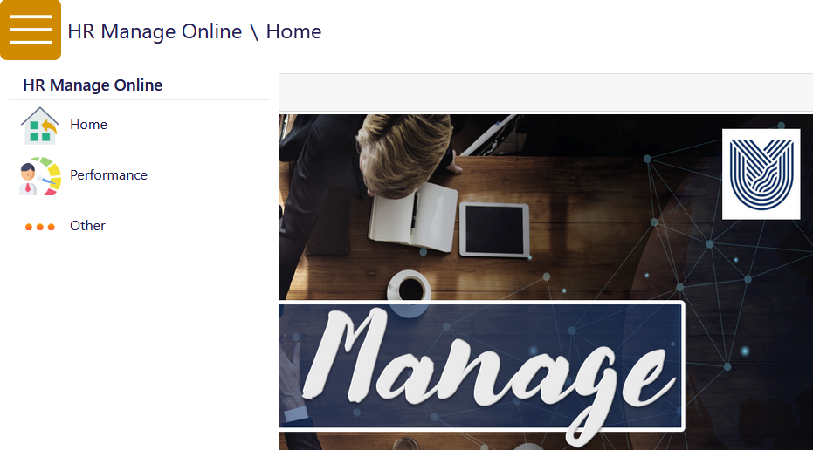

# Line Manager – Launch Performance Templates

As Line Manager, you must launch the new review cycle for your team members for each year. To do this, click on the green “Create New Review” icon

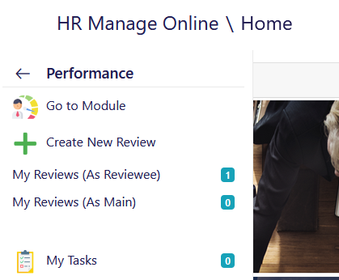

Click on the relevant cycle you have to launch

The next screen will appear. Click in the check box next to each of your team member’s names, click in the tick box “Start First Activity” and then click on “Create” to launch their reviews.

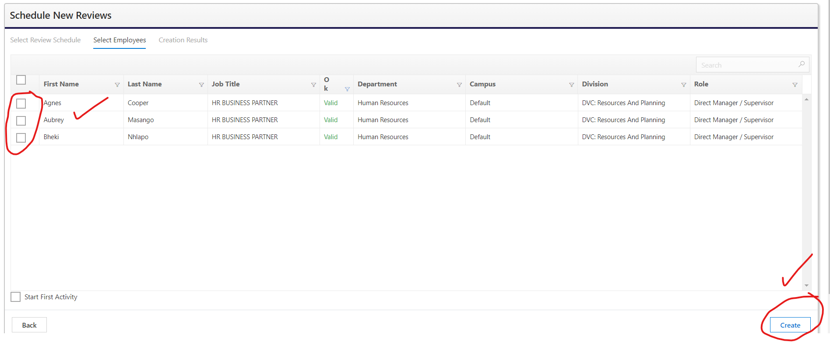

If the list of names that appear are incorrect, please contact your HRBP to assist.

Each of your Team Members will now receive an automatic email to notify them that you’ve launched their performance review process for the year.

You can now sign out: Click on your Initials and click on “Sign Out”

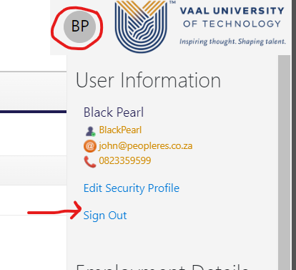

# Employee Complete Performance Agreement

Navigate to the following menu and click on My Reviews (As Reviewee)



Click the green “Open” button – this will take you to your Performance Contracting template.

## How to capture KPAs & Objective / Goals & Outputs.

Once you have opened this page, you may now edit your KPA’s & Objectives / Goals & Outputs.

Click on “View /Capture KPAs” icon and on your far-right, click on the pen and paper icon to edit your targets.

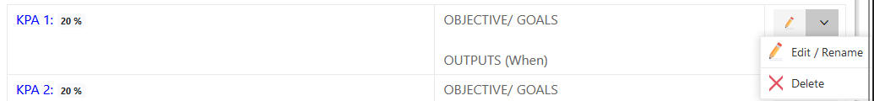

Edit your KPA & Objective/Goals & Outputs and save. (Copy and paste).

Capture your KPA in this space.

Assign a weighting. The total of all the KPAs should add up to 100

Capture your objective/goals & outputs (when)

Click “Save” and proceed to the next KPA

## Capture Comments

Click on the “Comments” icon.

The template will activate comment boxes where you can capture comments per KPA or the overall feedback/ comment at the bottom of the template. This activity is optional.

## Submit your template/results

Submit your review results – this action will send an automatic email to the participants in your review. (Both Line Manager and Employee will receive the same email). To action, click on the icon below.

The following email will be sent. If you receive this email and click on the link shown below, you will be taken back to the template.

## Sign Off

When final KPA’s & Objectives/Goals & Outputs have been agreed between team member and manager, then both need to sign off. To sign off, navigating to your performance review, click **Sign Off**

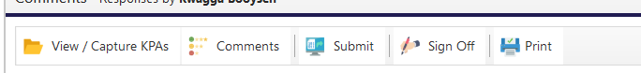

Complete the pop up screen (below).

The system will send an email notification to the participants to confirm that you’ve singed off.

# Line Manager Process

As a line manager, you must provide feedback and sign off the Performance Agreements of your Team members. To view the Performance Agreements of Team Members, click on the menu item “My Reviews (As Main)”.

This will open a list of all your Team Members, and you must open each one individually to comment and sign off.

Follow the steps above under point 4 to edit, comment and sign off on the Performance Agreement of each individual Team Member.

For any support, contact your HRBP.

End of Document.